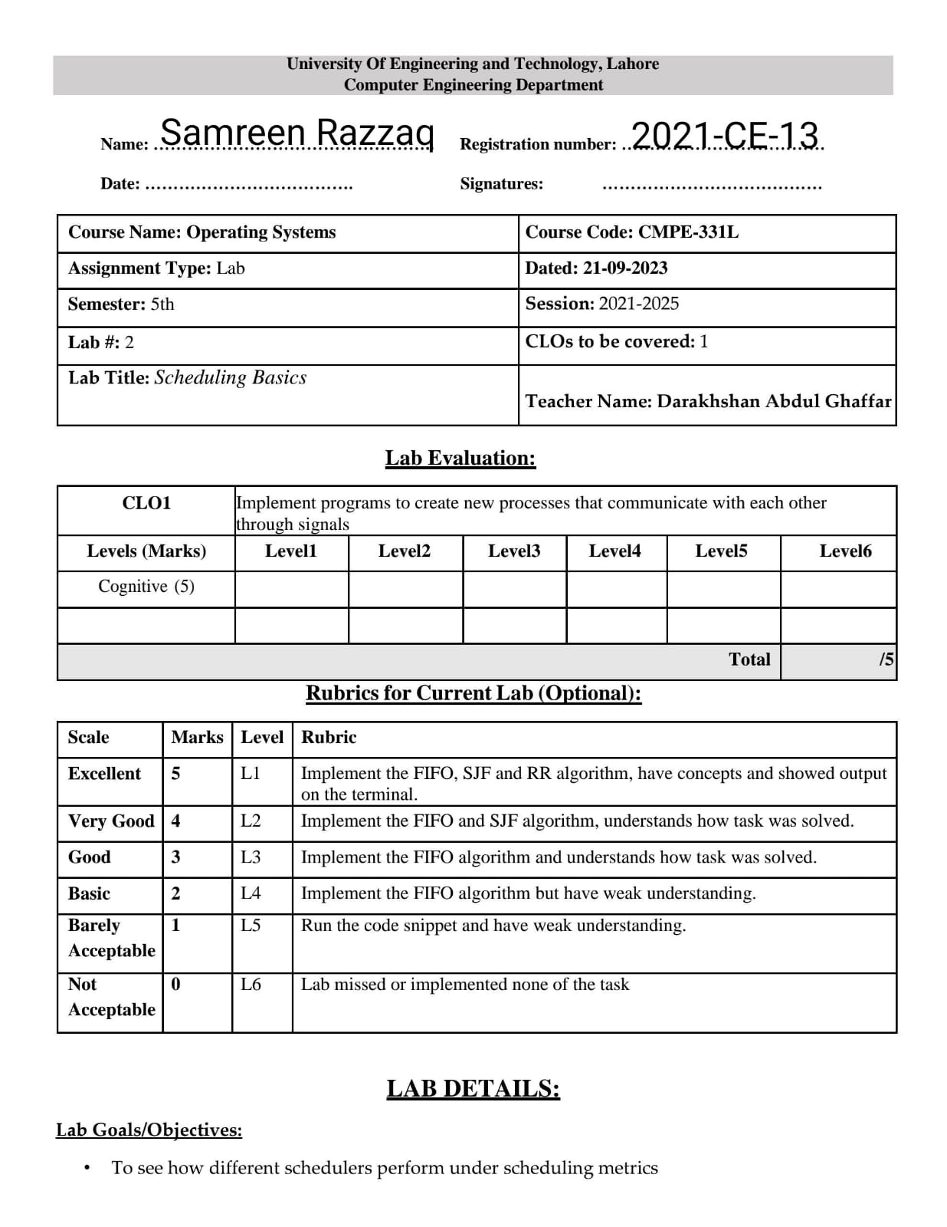

**Lab Tasks:**

1. **Compute the response time and turnaround time when running three jobs of length 200 with the SJF and FIFO schedulers.**

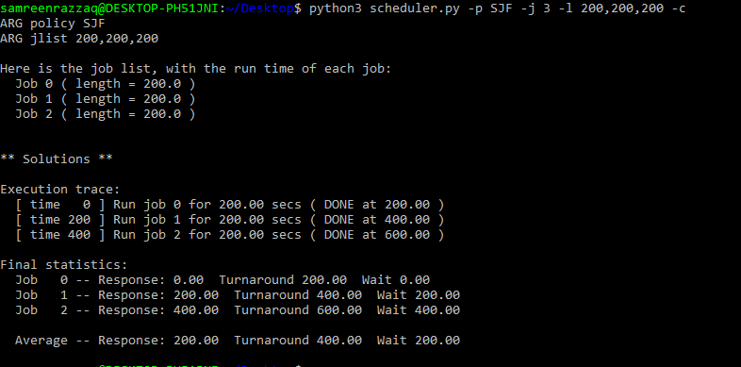By using SJF:

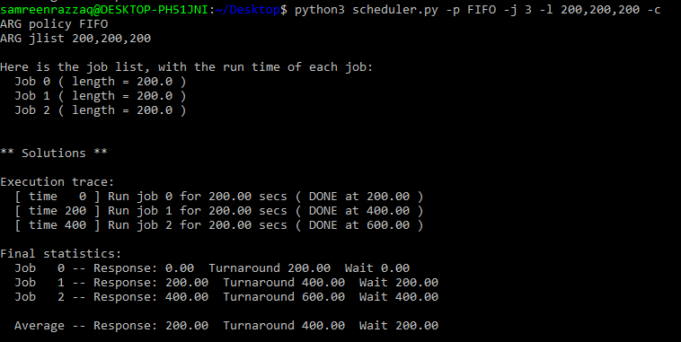By using FIFO:

1. **Now do the same but with jobs of different lengths: 100, 200, and 300.**

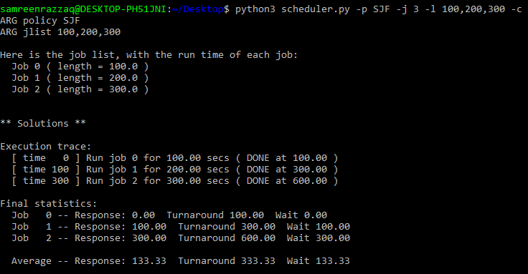By using SJF:

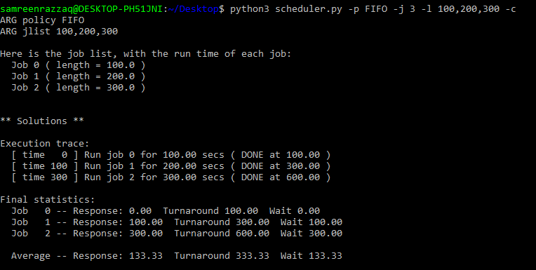By using FIFO:

1. **Now do the same, but also with the RR scheduler and a time-slice of 1.**

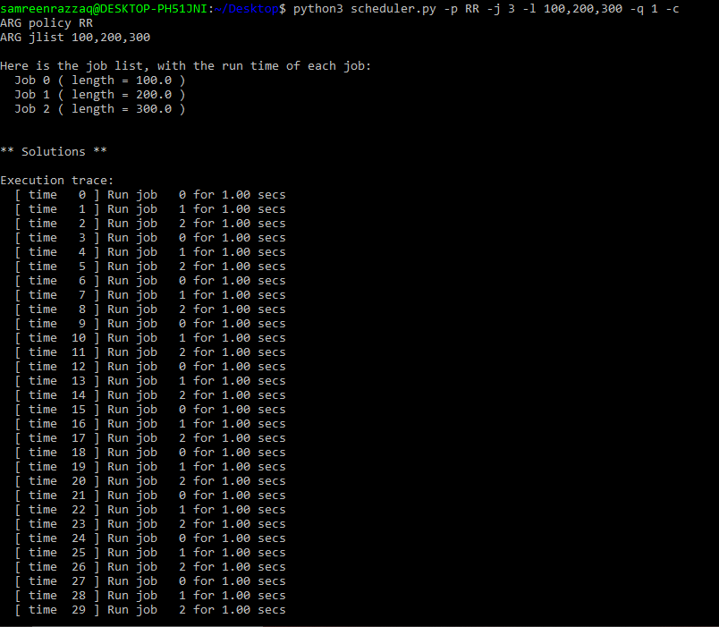

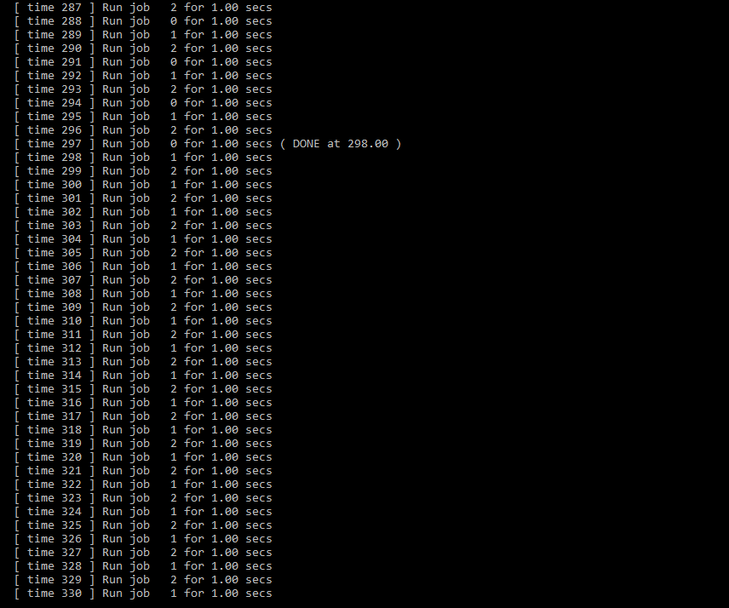

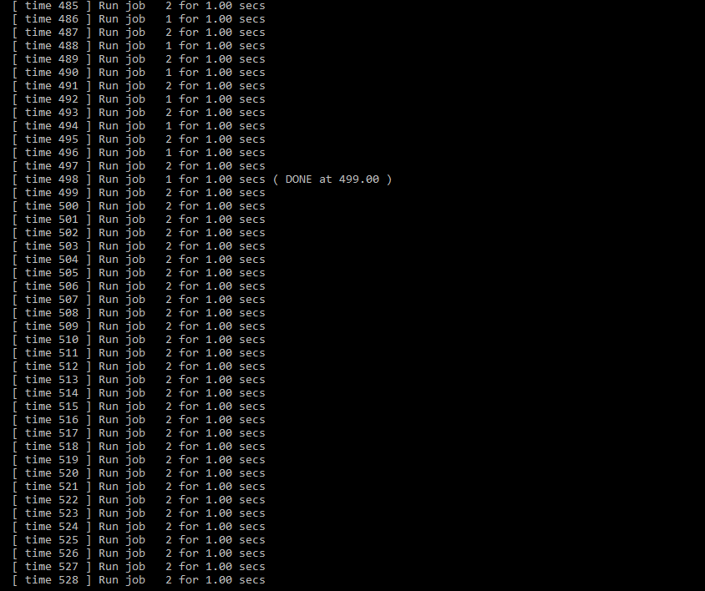

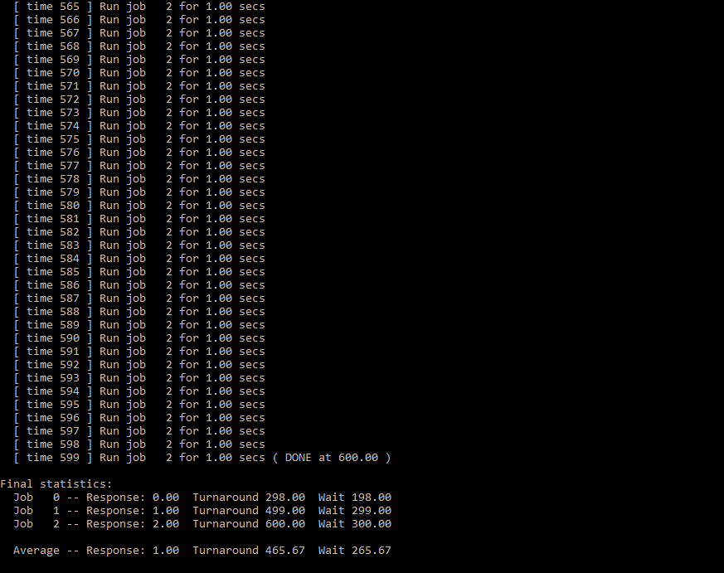

1. **What happens to response time with SJF as job lengths increase? Can you use the simulator to demonstrate the trend?**

We see that when we increase our length than the response become increase. It means length is directly proportional to the response. We can clearly see this:

* 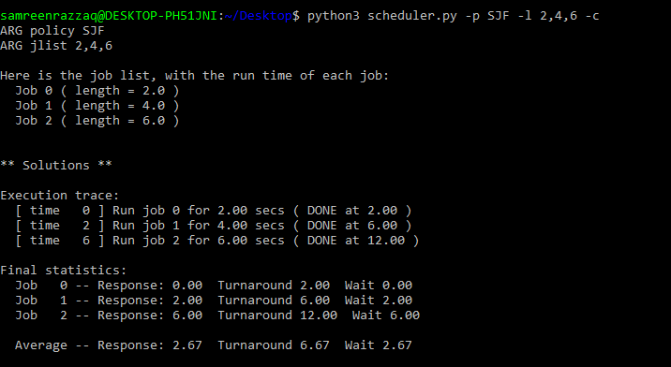By putting length: 2,4,6 Response = 2.67, Turnaround = 6.67
* By putting length: 4,8,12

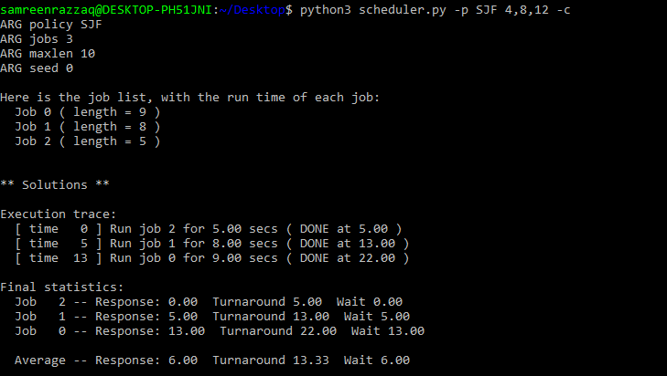Response = 6.00, Turnaround = 13.33

* By putting length: 8,16,24

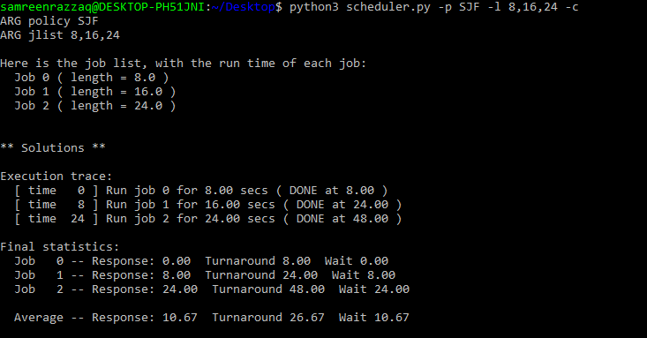 Response = 10.67, Turnaround = 26.67

* By putting length: 16,32,48

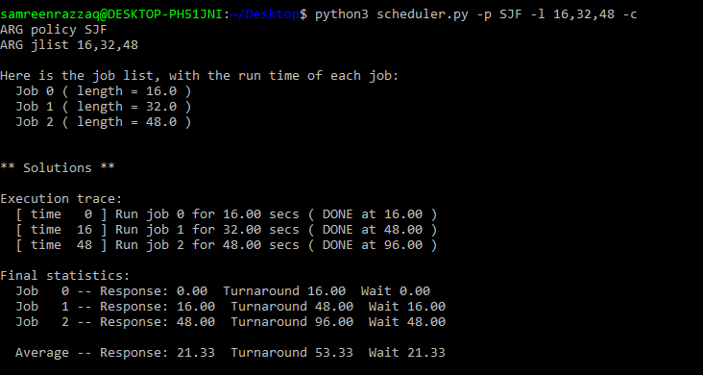 Response = 21.33, Turnaround = 53.33

1. **Implement the RR algorithm using the job list, with the run time of each job:**

**Job 0 (length = 1)**

**Job 1 (length = 4)**

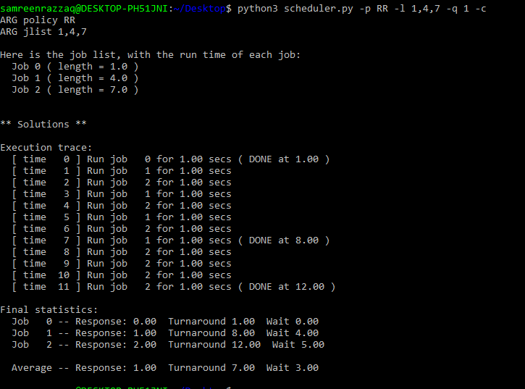**Job 2 (length = 7)**